**SQL_challenge_submission**

This SQL Challenge Submission has been prepared by Mike Murphy.

The instructions for the SQL Challenge can be found at the following link: -

<https://monash.bootcampcontent.com/monash-coding-bootcamp/monu-virt-data-11-2021-u-c/-/tree/master/02-Homework/09-SQL/Instructions>

This submission comprises the following elements: -

1. An image of the Entity Relationship Diagram for the Hewlett Packard “employeeSQL” database,
2. An SQL file of the Table Schemata code exported from QuickDBD,
3. A PostgreSQL file of the queries required for the SQL Challenge (including the Table Schemata code exported from QuickDBD,
4. Screenshots of the SQL Queries and their Results, and,
5. A Jupyter Notebook file of the Analysis required for the Bonus Part of the assignment.
6. The Entity Relationship Diagram

1. The Table Schemata Code Exported from QuickDBD

-- Exported from QuickDBD: https://www.quickdatabasediagrams.com/

-- NOTE! If you have used non-SQL datatypes in your design, you will have to change these here.

DROP TABLE departments CASCADE;

DROP TABLE employees CASCADE;

DROP TABLE dept_manager;

DROP TABLE dept_emps;

DROP TABLE titles;

DROP TABLE salaries;

CREATE TABLE "departments" (

    "dept_no" varchar   NOT NULL,

    "dept_name" varchar   NOT NULL,

    CONSTRAINT "pk_departments" PRIMARY KEY (

        "dept_no"

     )

);

CREATE TABLE "employees" (

    "emp_no" int   NOT NULL,

    "title_id" varchar   NOT NULL,

    "birth_date" date   NOT NULL,

    "first_name" varchar   NOT NULL,

    "last_name" varchar   NOT NULL,

    "gender" varchar   NOT NULL,

    "hire_date" date   NOT NULL,

    CONSTRAINT "pk_employees" PRIMARY KEY (

        "emp_no"

     )

);

CREATE TABLE "dept_manager" (

    "dept_no" varchar   NOT NULL,

    "emp_no" int   NOT NULL

);

CREATE TABLE "dept_emps" (

    "emp_no" int   NOT NULL,

    "dept_no" varchar   NOT NULL

);

CREATE TABLE "titles" (

    "title_id" varchar   NOT NULL,

    "title" varchar   NOT NULL,

    CONSTRAINT "pk_titles" PRIMARY KEY (

        "title_id")

);

CREATE TABLE "salaries" (

    "emp_no" int   NOT NULL,

    "salary" int   NOT NULL

);

ALTER TABLE "dept_manager" ADD CONSTRAINT "fk_dept_manager_dept_no" FOREIGN KEY("dept_no")

REFERENCES "departments" ("dept_no");

ALTER TABLE "dept_manager" ADD CONSTRAINT "fk_dept_manager_emp_no" FOREIGN KEY("emp_no")

REFERENCES "employees" ("emp_no");

ALTER TABLE "dept_emps" ADD CONSTRAINT "fk_dept_emps_emp_no" FOREIGN KEY("emp_no")

REFERENCES "employees" ("emp_no");

ALTER TABLE "dept_emps" ADD CONSTRAINT "fk_dept_emps_dept_no" FOREIGN KEY("dept_no")

REFERENCES "departments" ("dept_no");

ALTER TABLE "titles" ADD CONSTRAINT "fk_titles_title_id" FOREIGN KEY("title_id")

REFERENCES "employees" ("title_id");

ALTER TABLE "salaries" ADD CONSTRAINT "fk_salaries_emp_no" FOREIGN KEY("emp_no")

REFERENCES "employees" ("emp_no");

1. The PostgreSQL File of the Queries Required for the SQL Challenge

-- Exported from QuickDBD: https://www.quickdatabasediagrams.com/

-- NOTE! If you have used non-SQL datatypes in your design, you will have to change these here.

DROP TABLE departments CASCADE;

DROP TABLE employees CASCADE;

DROP TABLE dept_manager;

DROP TABLE dept_emps;

DROP TABLE titles;

DROP TABLE salaries;

CREATE TABLE "departments" (

    "dept_no" varchar   NOT NULL,

    "dept_name" varchar   NOT NULL,

    CONSTRAINT "pk_departments" PRIMARY KEY (

        "dept_no"

     )

);

CREATE TABLE "employees" (

    "emp_no" int   NOT NULL,

    "emp_title_id" varchar   NOT NULL,

    "birth_date" date   NOT NULL,

    "first_name" varchar   NOT NULL,

    "last_name" varchar   NOT NULL,

    "gender" varchar   NOT NULL,

    "hire_date" date   NOT NULL,

    CONSTRAINT "pk_employees" PRIMARY KEY (

        "emp_no"

     )

);

CREATE TABLE "dept_manager" (

    "dept_no" varchar   NOT NULL,

    "emp_no" int   NOT NULL

);

CREATE TABLE "dept_emps" (

    "emp_no" int   NOT NULL,

    "dept_no" varchar   NOT NULL

);

CREATE TABLE "titles" (

    "title_id" varchar   NOT NULL,

    "title" varchar   NOT NULL,

    CONSTRAINT "pk_titles" PRIMARY KEY (

        "title_id")

);

CREATE TABLE "salaries" (

    "emp_no" int   NOT NULL,

    "salary" int   NOT NULL

);

-- manually imported departments

SELECT * FROM departments

-- verified departments

-- manually imported employees

SELECT * FROM employees LIMIT 10

-- verified employees

-- manually imported dept_manager

SELECT * FROM dept_manager LIMIT 10

-- verified dept_manager

-- manually imported dept_emps

SELECT * FROM dept_emps LIMIT 10

-- verified dept_emps

-- manually imported titles

SELECT * FROM titles LIMIT 10

-- verified titles

-- manually imported salaries

SELECT * FROM salaries LIMIT 10

-- verified salaries

-- now create constraints

ALTER TABLE "dept_manager" ADD CONSTRAINT "fk_dept_manager_dept_no" FOREIGN KEY("dept_no")

REFERENCES "departments" ("dept_no");

ALTER TABLE "dept_manager" ADD CONSTRAINT "fk_dept_manager_emp_no" FOREIGN KEY("emp_no")

REFERENCES "employees" ("emp_no");

ALTER TABLE "salaries" ADD CONSTRAINT "fk_salaries_emp_no" FOREIGN KEY("emp_no")

REFERENCES "employees" ("emp_no");

ALTER TABLE "employees" ADD CONSTRAINT "fk_employees_emp_title_id" FOREIGN KEY("emp_title_id")

REFERENCES "titles" ("title_id");

ALTER TABLE "dept_emps" ADD CONSTRAINT "fk_dept_emp_emp_no" FOREIGN KEY("emp_no")

REFERENCES "employees" ("emp_no");

ALTER TABLE "dept_emps" ADD CONSTRAINT "fk_dept_emp_dept_no" FOREIGN KEY("dept_no")

REFERENCES "departments" ("dept_no");

--1.   List the following details of each employee: employee number, last name, first name, sex, and salary.

SELECT employees.emp_no, employees.last_name, employees.first_name, employees.gender, salaries.salary

FROM employees

JOIN salaries

ON employees.emp_no = salaries.emp_no

LIMIT (10);

-- returns 300,024 rows consistent with original csv file

--2.   List first name, last name, and hire date for employees who were hired in 1986.

SELECT first_name, last_name, hire_date

FROM employees

WHERE hire_date BETWEEN '1/1/1986' AND '12/31/1986'

ORDER BY hire_date

LIMIT (10);

-- returns 36,150 rows

--3.   List the manager of each department with the following information: department number, department name, the manager's employee number, last name, first name.

SELECT departments.dept_no, departments.dept_name, dept_manager.emp_no, employees.last_name, employees.first_name

FROM departments

JOIN dept_manager

ON departments.dept_no = dept_manager.dept_no

JOIN employees

ON dept_manager.emp_no = employees.emp_no

LIMIT (10);

-- returns 24 rows

--4.   List the department of each employee with the following information: employee number, last name, first name, and department name.

SELECT dept_emps.emp_no, employees.last_name, employees.first_name, departments.dept_name

FROM dept_emps

JOIN employees

ON dept_emps.emp_no = employees.emp_no

JOIN departments

ON dept_emps.dept_no = departments.dept_no

LIMIT (10);

-- returns 331,603 rows

--5.  List first name, last name, and sex for employees whose first name is "Hercules" and last names begin with "B."

SELECT employees.first_name, employees.last_name, employees.gender

FROM employees

WHERE first_name = 'Hercules'

AND last_name Like 'B%'

LIMIT (10);

-- returns 20 rows

--6.   List all employees in the Sales department, including their employee number, last name, first name, and department name.

SELECT departments.dept_name, employees.last_name, employees.first_name

FROM dept_emps

JOIN employees

ON dept_emps.emp_no = employees.emp_no

JOIN departments

ON dept_emps.dept_no = departments.dept_no

WHERE departments.dept_name = 'Sales'

LIMIT (10);

-- returns 53,245 rows

--7.   List all employees in the Sales and Development departments, including their employee number, last name, first name, and department name.

SELECT employees.emp_no, employees.last_name, employees.first_name, departments.dept_name

FROM dept_emps

JOIN employees

ON dept_emps.emp_no = employees.emp_no

JOIN departments

ON dept_emps.dept_no = departments.dept_no

WHERE departments.dept_name = 'Sales'

OR departments.dept_name = 'Development'

LIMIT (10);

-- returns 137,952 rows

--8.   In descending order, list the frequency count of employee last names, i.e., how many employees share each last name.

SELECT last_name,

COUNT(last_name) AS "frequency"

FROM employees

GROUP BY last_name

ORDER BY

COUNT(last_name) DESC

LIMIT (10);

-- 1638 rows

---------------------------END OF DATA ANALYSIS--------------------------------

-------------------------------START OF BONUS----------------------------------

--BONUS COMPLETED IN PANDAS - REFER ACCOMPANYING JUPYTER NOTEBOOK--------------

1. The Screenshots of the SQL Queries and their Results

The screenshots of the SQL Queries and their Results required for the SQL Challenge follow.

***--1. List the following details of each employee: employee number, last name, first name, sex, and salary***.

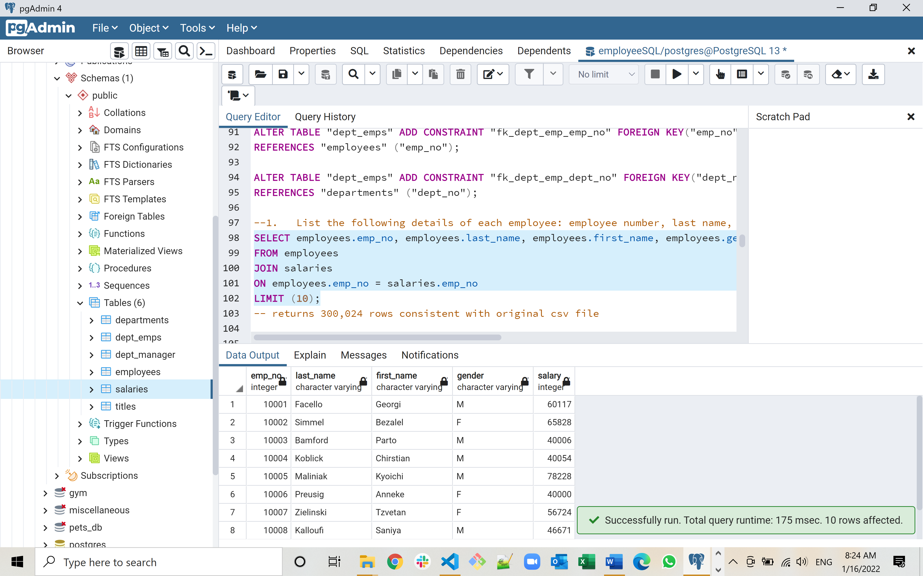

**--2. List first name, last name, and hire date for employees who were hired in 1986.**

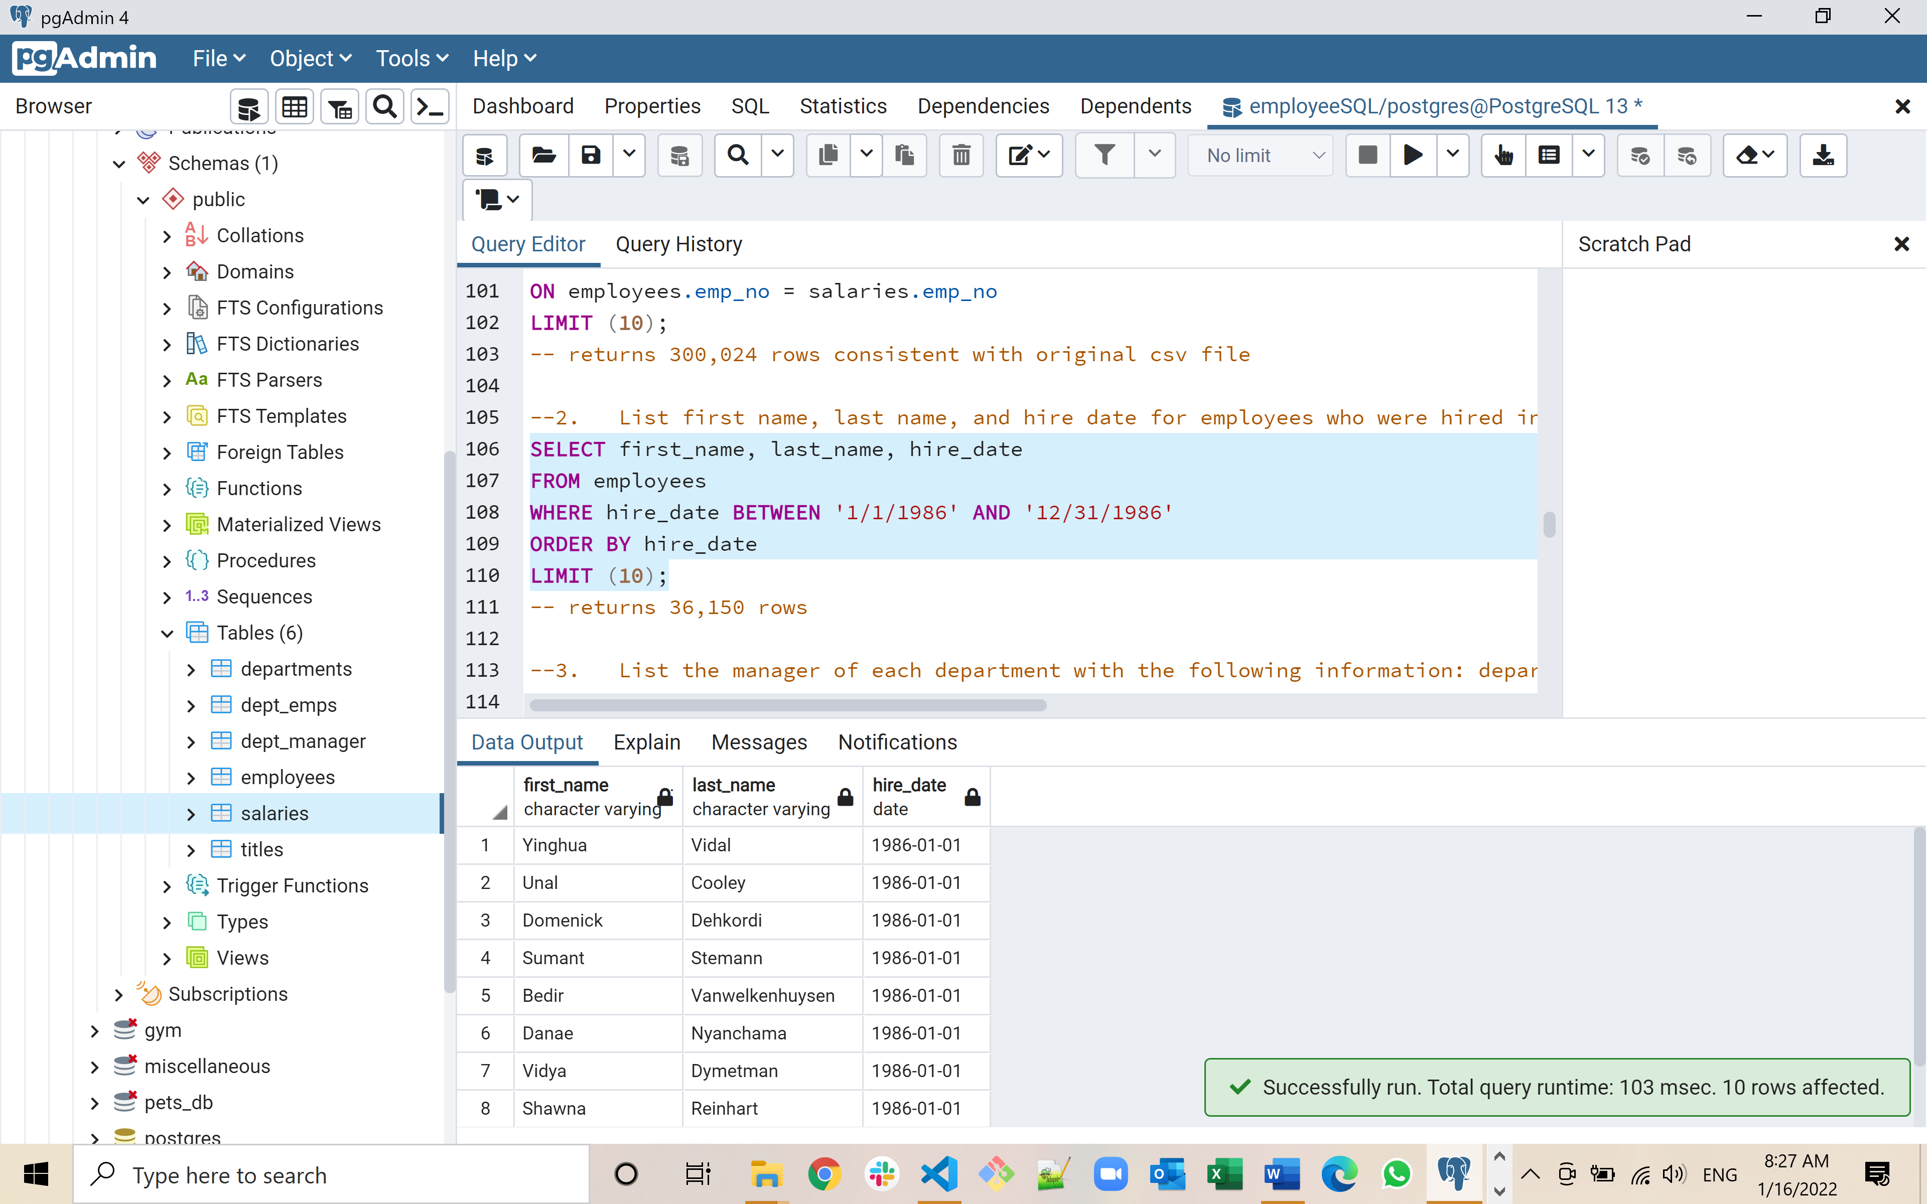

**--3. List the manager of each department with the following information: department number, department name, the manager's employee number, last name, first name.**

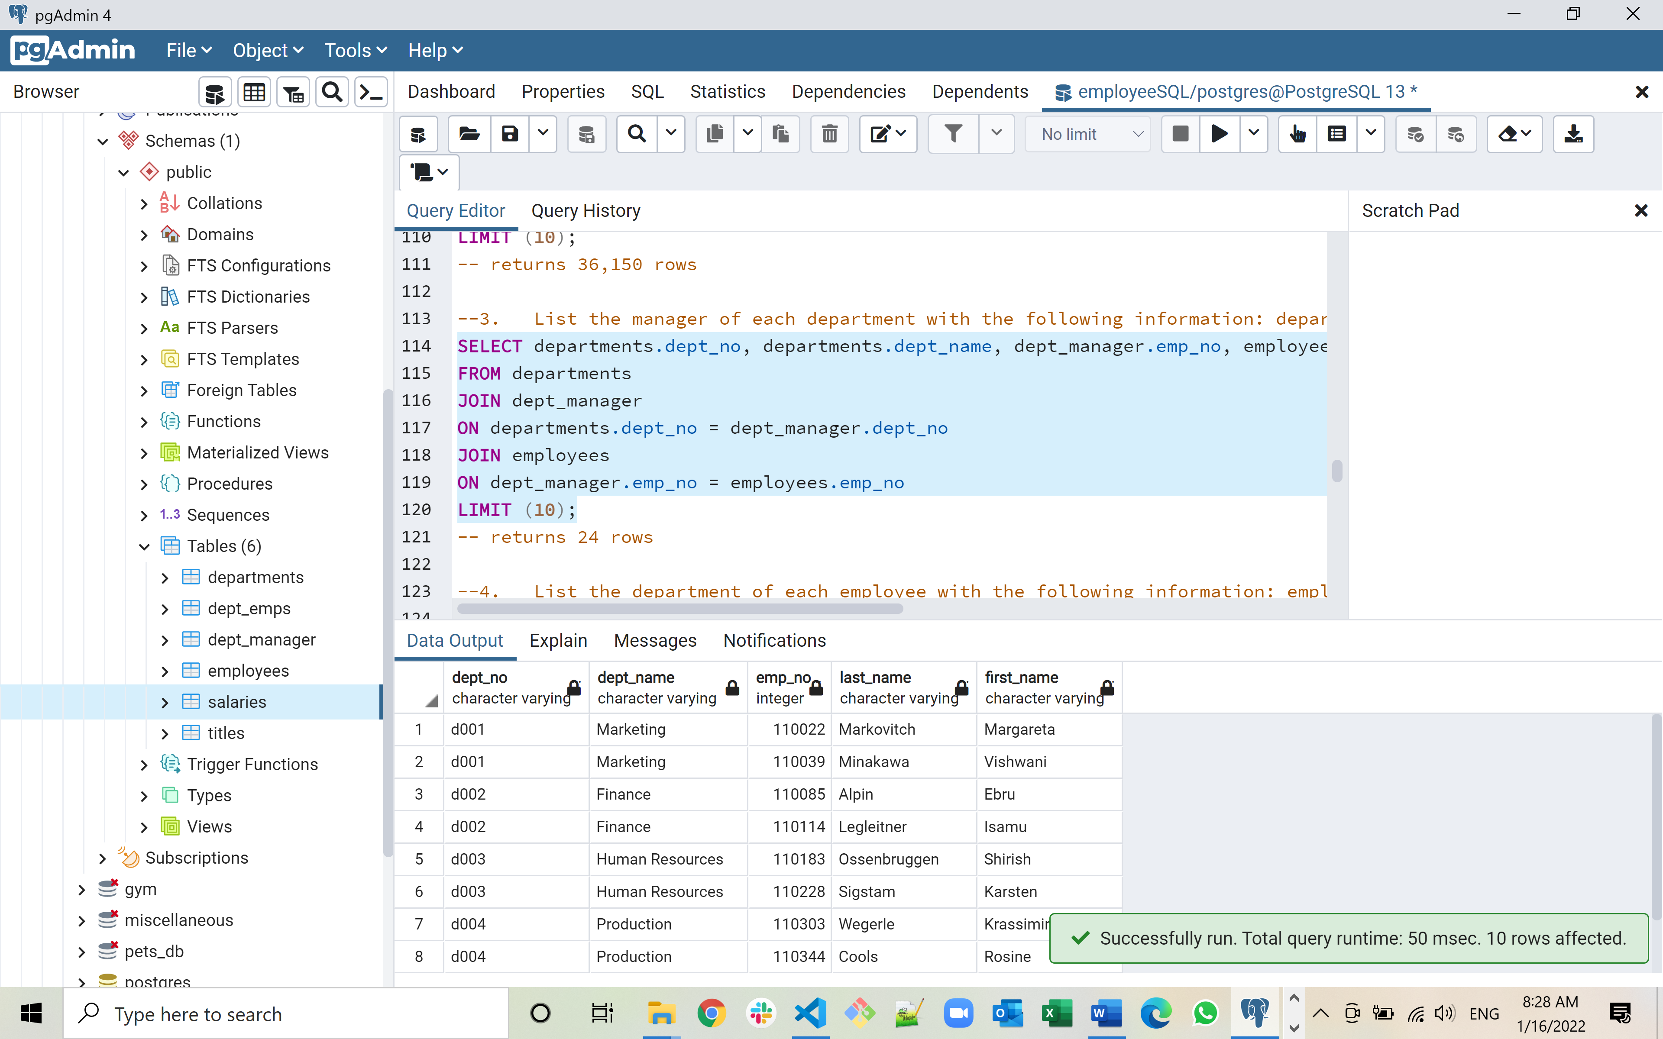

**--4. List the department of each department with the following information: employee number, last name, first name and department name.**

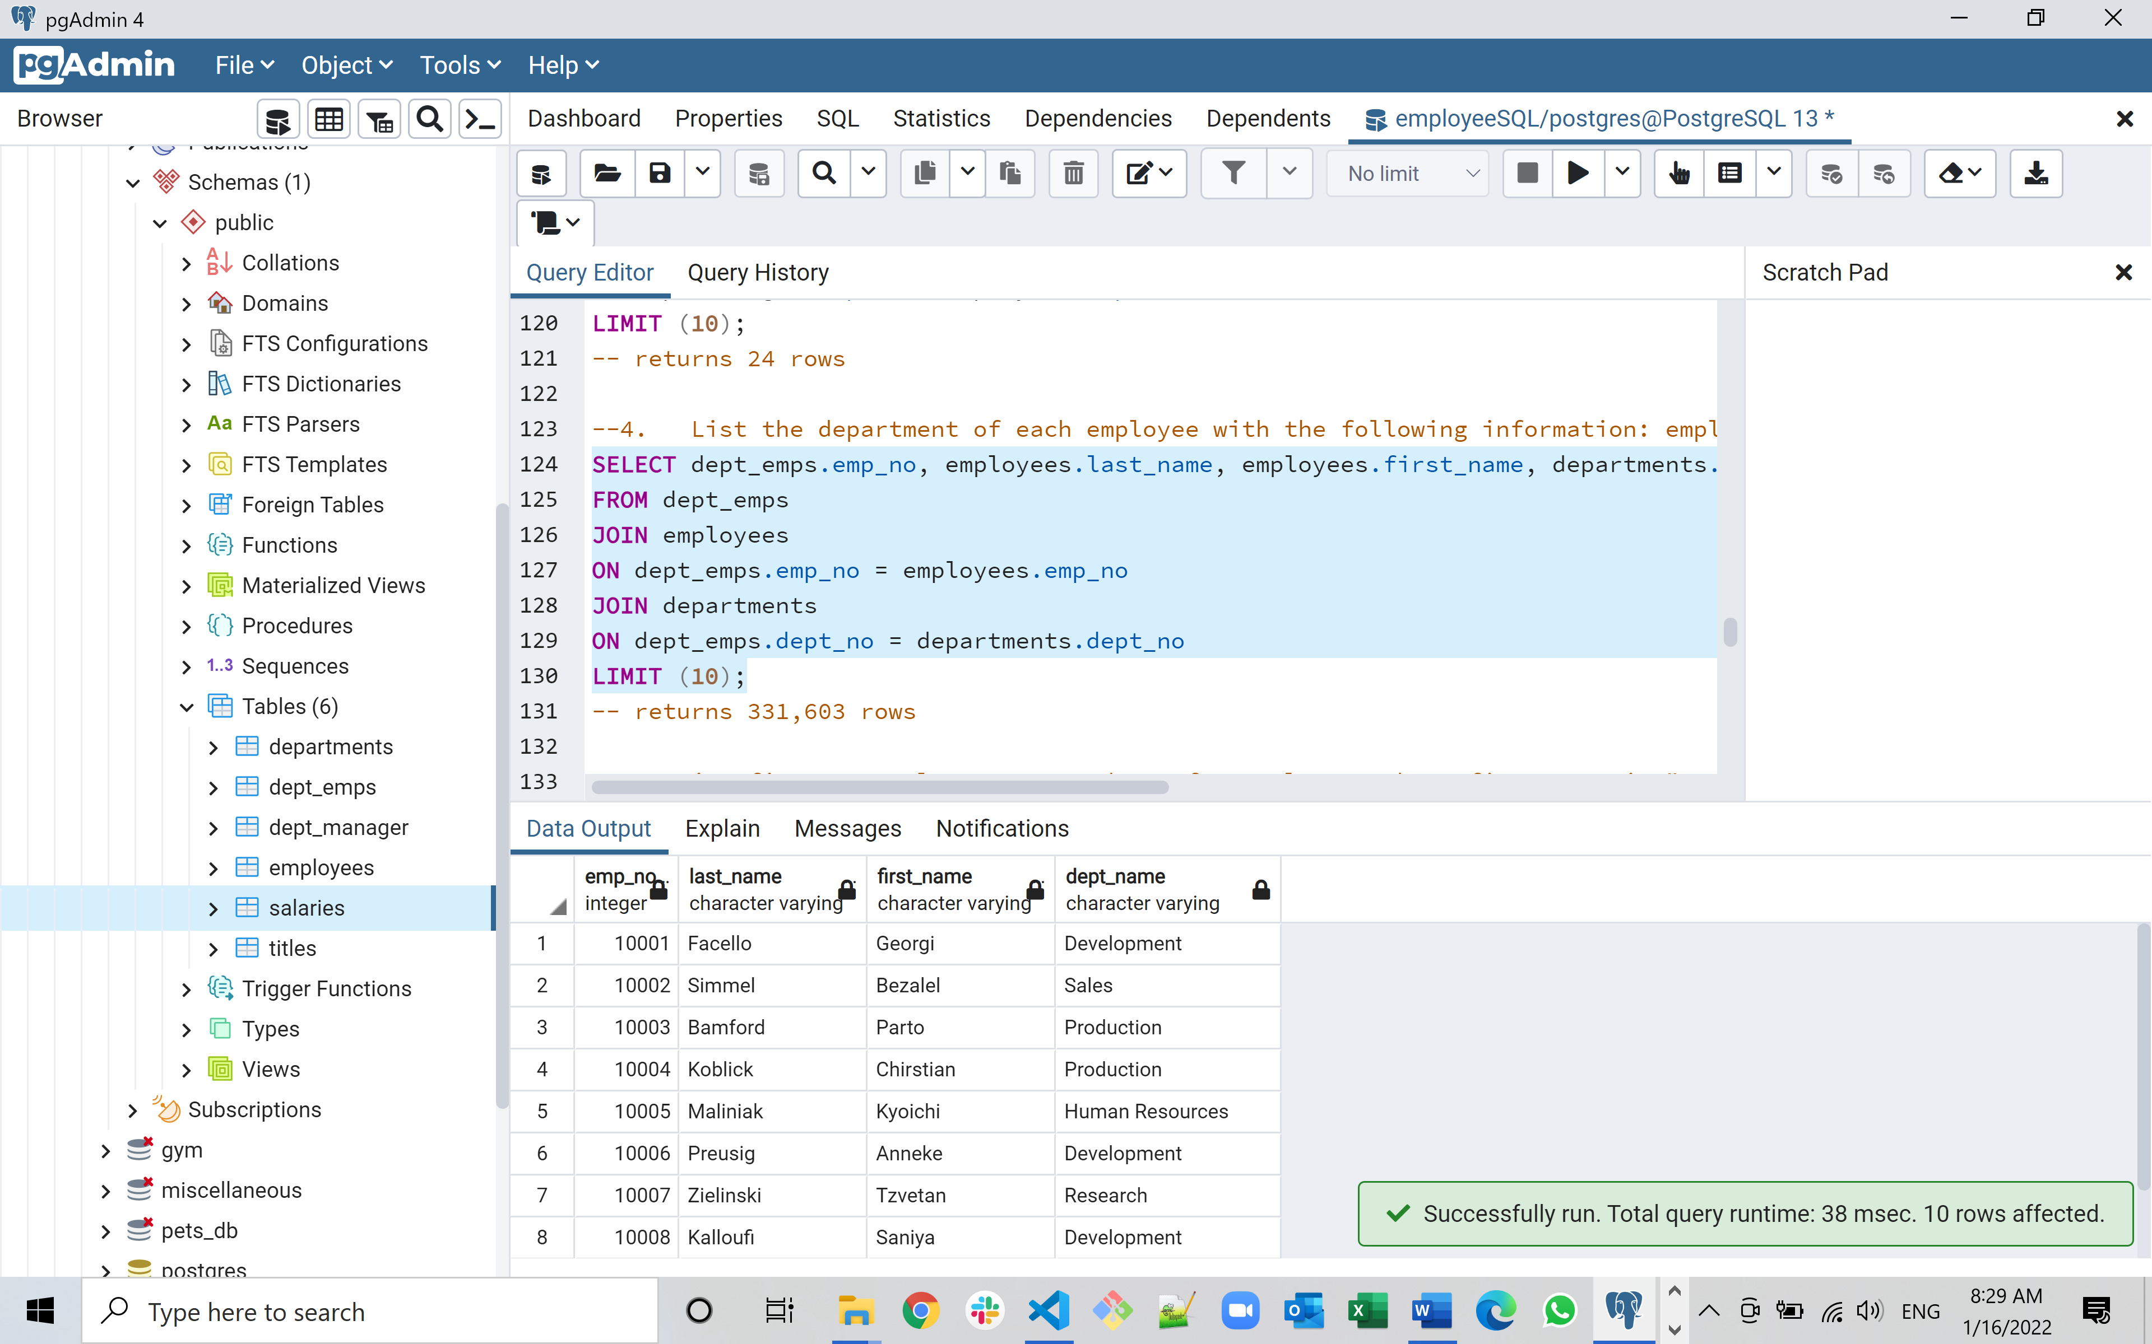

**--5. List first name, last name, and sex for employees whose first name is "Hercules" and last names begin with "B."**

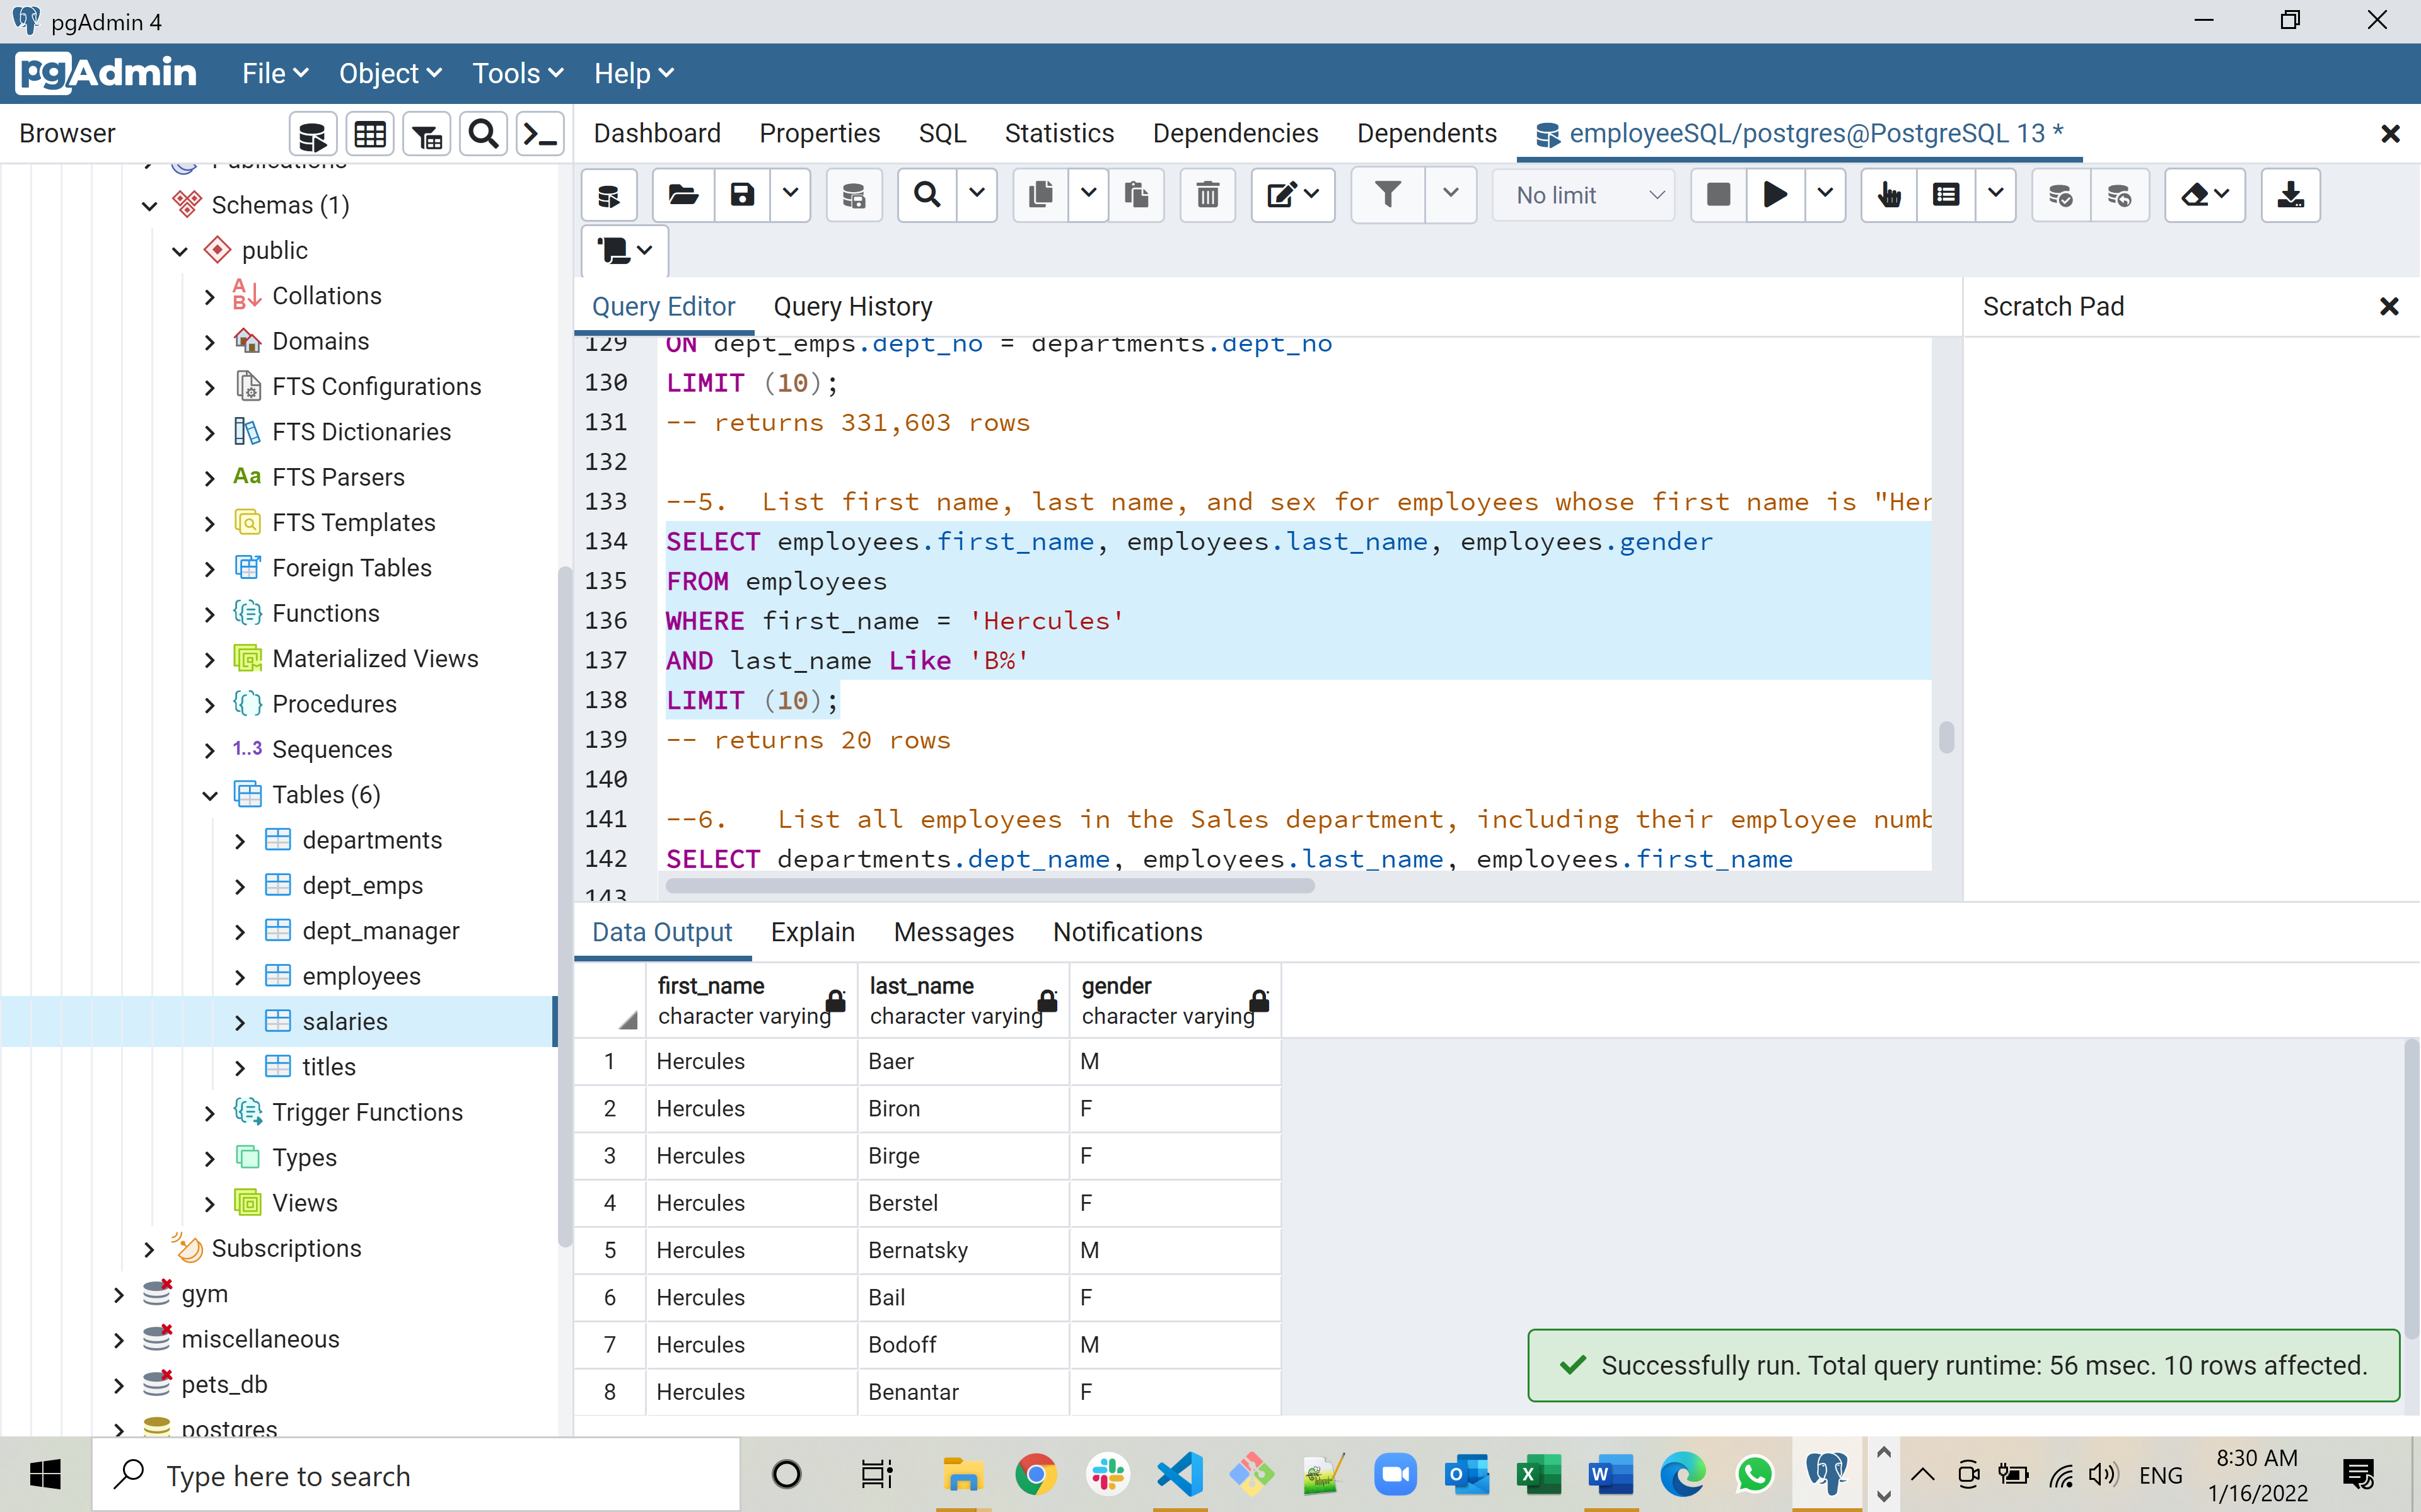

**--6. List all employees in the Sales department, including their employee number, last name, first name, and department name.**

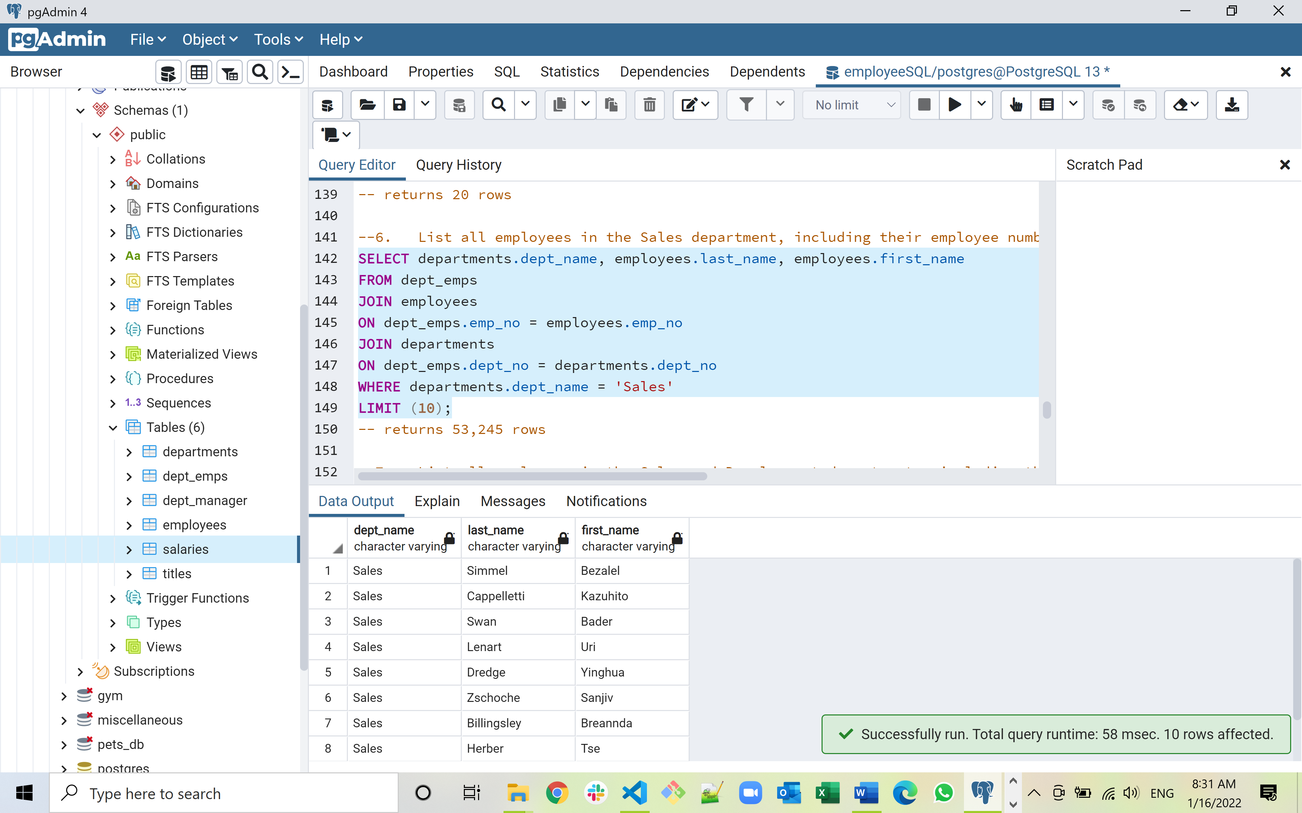

**--7. List all employees in the Sales and Development departments, including their employee number, last name, first name, and department name.**

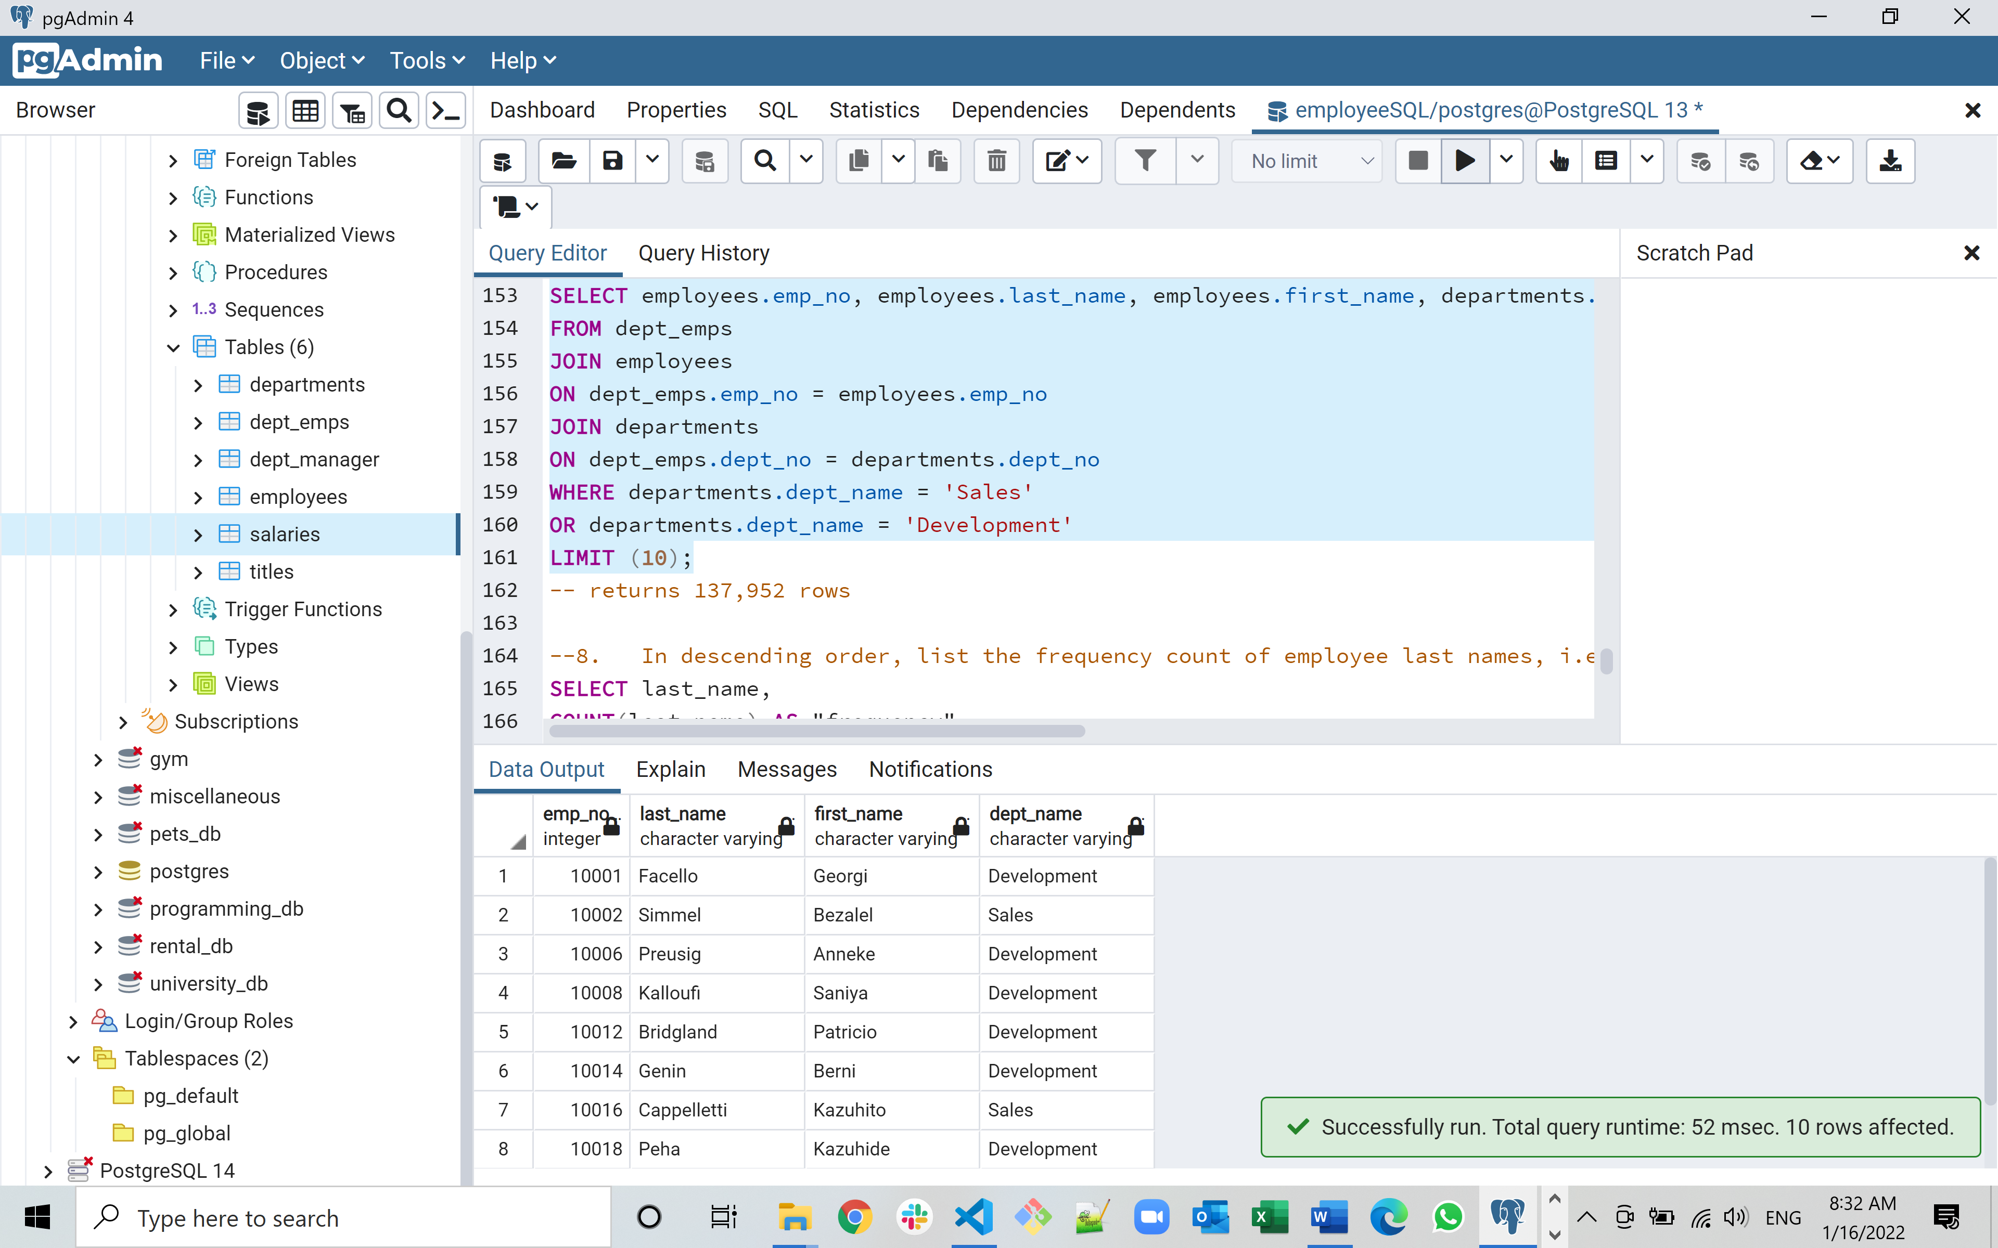

**--8. In descending order, list the frequency count of employee last names, i.e., how many employees share each last name.**

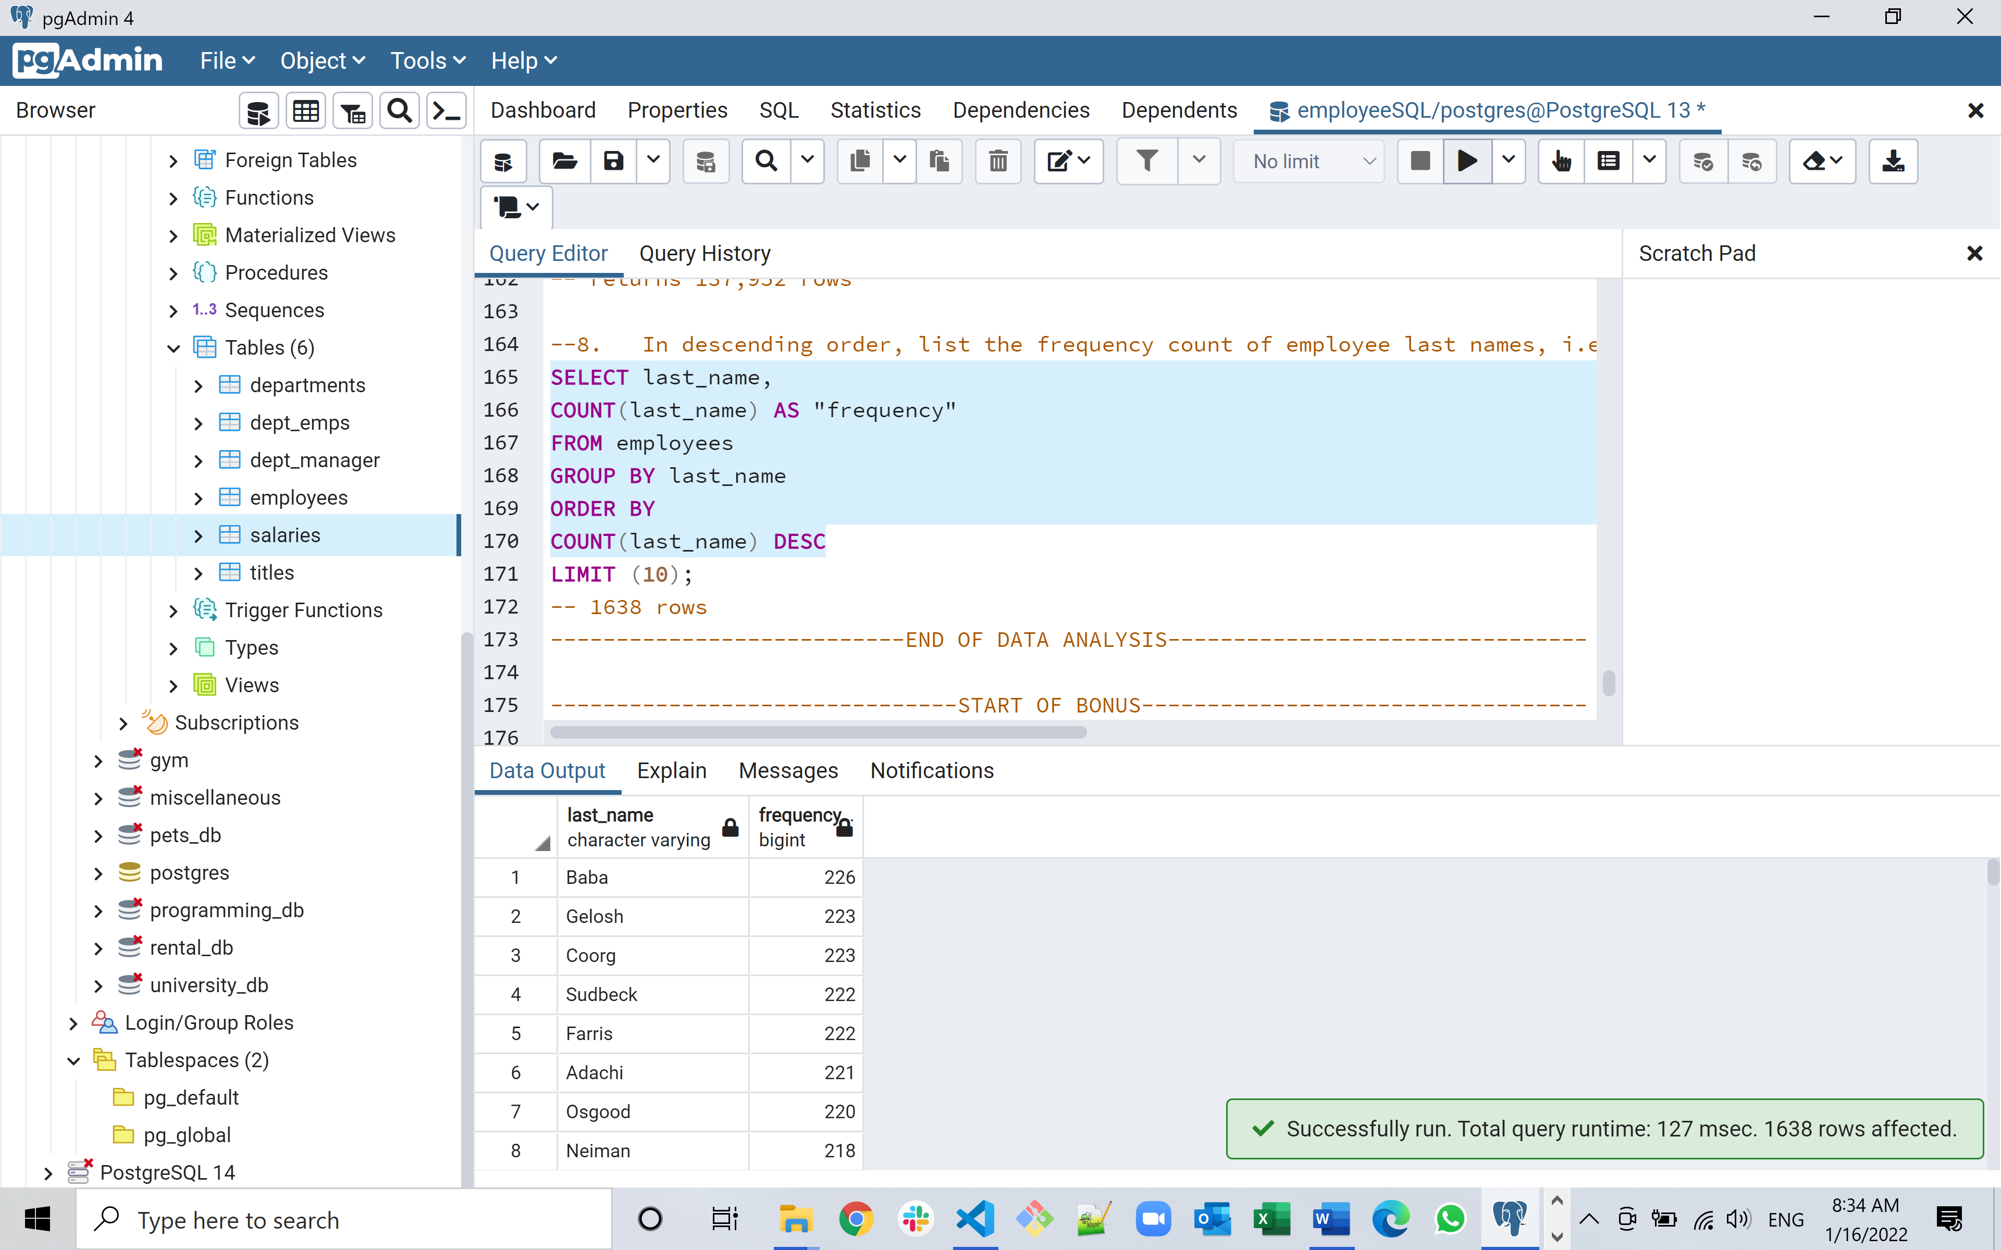

1. The Jupyter Notebook file of the Analysis required for the Bonus Part of the assignment

*# import dependencies*

**from** sqlalchemy **import** create_engine

**import** pandas **as** pd

**import** matplotlib.pyplot **as** plt

**import** numpy **as** np

**import** psycopg2

**from** config **import** un

**from** config **import** pw

**from** config **import** dbn

In [2]:

*# configure the SQLAlchemy engine to interact with the database*

engine **=** create_engine('postgresql://localhost:5432/EmployeeSQL')

connection **=** psycopg2**.**connect(user**=**un, password**=**pw, dbname**=**dbn)

In [3]:

*# read the 'employeeSQL' database for 'employees', unique 'titles', 'salary' information and replace NaNs*

*# first get salaries*

salaries_df **=** pd**.**read_sql("SELECT * FROM salaries", connection)

salaries_df**.**fillna(0)

salaries_df**.**head()

Out[3]:

|  | **emp_no** | **salary** |
| --- | --- | --- |
| **0** | 10001 | 60117 |
| **1** | 10002 | 65828 |
| **2** | 10003 | 40006 |
| **3** | 10004 | 40054 |
| **4** | 10005 | 78228 |

In [4]:

*# create a histogram to visualise the most common salary ranges for employees*

salaries_df**.**hist(column**=**'salary', figsize**=**[10,6], color**=**['blue'])

plt**.**xlabel('Salary Range')

plt**.**ylabel('Number of Employees per Range')

plt**.**title('Distribution of Salary Ranges')

Out[4]:

Text(0.5, 1.0, 'Distribution of Salary Ranges')

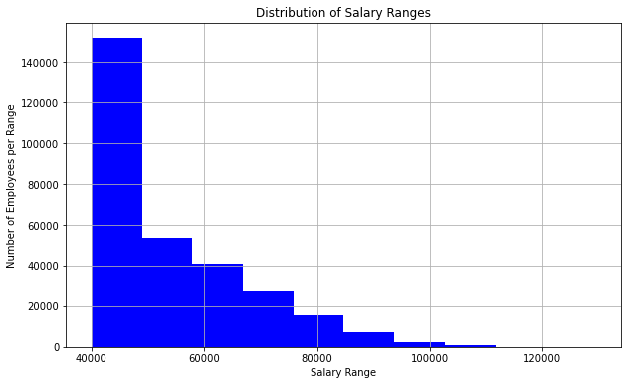

In [5]:

*# read the 'employeeSQL' database for 'employees', unique 'titles' and 'salary' information and replace NaNs*

*# next get employees*

employees_df **=** pd**.**read_sql("SELECT * FROM employees", connection)

employees_df**.**fillna(0)

employees_df**.**head()

Out[5]:

|  | **emp_no** | **emp_title_id** | **birth_date** | **first_name** | **last_name** | **gender** | **hire_date** |
| --- | --- | --- | --- | --- | --- | --- | --- |
| **0** | 473302 | s0001 | 1953-07-25 | Hideyuki | Zallocco | M | 1990-04-28 |
| **1** | 475053 | e0002 | 1954-11-18 | Byong | Delgrande | F | 1991-09-07 |
| **2** | 57444 | e0002 | 1958-01-30 | Berry | Babb | F | 1992-03-21 |
| **3** | 421786 | s0001 | 1957-09-28 | Xiong | Verhoeff | M | 1987-11-26 |
| **4** | 282238 | e0003 | 1952-10-28 | Abdelkader | Baumann | F | 1991-01-18 |

In [6]:

*# read the 'employeeSQL' database for 'employees', unique 'titles', 'salary' information and replace NaNs*

*# next get all titles from 'titles'*

titles_df **=** pd**.**read_sql("SELECT * FROM titles", connection)

titles_df**.**fillna(0)

titles_df

Out[6]:

|  | **title_id** | **title** |
| --- | --- | --- |
| **0** | s0001 | Staff |
| **1** | s0002 | Senior Staff |
| **2** | e0001 | Assistant Engineer |
| **3** | e0002 | Engineer |
| **4** | e0003 | Senior Engineer |
| **5** | e0004 | Technique Leader |
| **6** | m0001 | Manager |

In [7]:

*# rename employee emp_title_id so that we can merge on title_id*

employees_df**.**rename(columns**=**{'emp_title_id': 'title_id'}, inplace**=True**)

employees_df**.**head()

Out[7]:

|  | **emp_no** | **title_id** | **birth_date** | **first_name** | **last_name** | **gender** | **hire_date** |
| --- | --- | --- | --- | --- | --- | --- | --- |
| **0** | 473302 | s0001 | 1953-07-25 | Hideyuki | Zallocco | M | 1990-04-28 |
| **1** | 475053 | e0002 | 1954-11-18 | Byong | Delgrande | F | 1991-09-07 |
| **2** | 57444 | e0002 | 1958-01-30 | Berry | Babb | F | 1992-03-21 |
| **3** | 421786 | s0001 | 1957-09-28 | Xiong | Verhoeff | M | 1987-11-26 |
| **4** | 282238 | e0003 | 1952-10-28 | Abdelkader | Baumann | F | 1991-01-18 |

In [8]:

*# now merge employees and titles*

employee_titles_df **=** pd**.**merge(employees_df,titles_df,on**=**"title_id")

employee_titles_df

Out[8]:

|  | **emp_no** | **title_id** | **birth_date** | **first_name** | **last_name** | **gender** | **hire_date** | **title** |
| --- | --- | --- | --- | --- | --- | --- | --- | --- |
| **0** | 473302 | s0001 | 1953-07-25 | Hideyuki | Zallocco | M | 1990-04-28 | Staff |
| **1** | 421786 | s0001 | 1957-09-28 | Xiong | Verhoeff | M | 1987-11-26 | Staff |
| **2** | 273487 | s0001 | 1957-04-14 | Christoph | Parfitt | M | 1991-06-28 | Staff |
| **3** | 246449 | s0001 | 1958-03-23 | Subbu | Bultermann | F | 1988-03-25 | Staff |
| **4** | 48085 | s0001 | 1964-01-19 | Venkatesan | Gilg | M | 1993-06-28 | Staff |
| **...** | ... | ... | ... | ... | ... | ... | ... | ... |
| **300019** | 111400 | m0001 | 1959-11-09 | Arie | Staelin | M | 1985-01-01 | Manager |
| **300020** | 111133 | m0001 | 1955-03-16 | Hauke | Zhang | M | 1986-12-30 | Manager |
| **300021** | 110085 | m0001 | 1959-10-28 | Ebru | Alpin | M | 1985-01-01 | Manager |
| **300022** | 110386 | m0001 | 1953-10-04 | Shem | Kieras | M | 1988-10-14 | Manager |
| **300023** | 111784 | m0001 | 1956-06-14 | Marjo | Giarratana | F | 1988-02-12 | Manager |

300024 rows × 8 columns

In [9]:

*# now merge employees / titles with salaries*

employee_titles_salaries_df **=** pd**.**merge(employee_titles_df,salaries_df,on**=**"emp_no")

employee_titles_salaries_df

Out[9]:

|  | **emp_no** | **title_id** | **birth_date** | **first_name** | **last_name** | **gender** | **hire_date** | **title** | **salary** |
| --- | --- | --- | --- | --- | --- | --- | --- | --- | --- |
| **0** | 473302 | s0001 | 1953-07-25 | Hideyuki | Zallocco | M | 1990-04-28 | Staff | 40000 |
| **1** | 421786 | s0001 | 1957-09-28 | Xiong | Verhoeff | M | 1987-11-26 | Staff | 40000 |
| **2** | 273487 | s0001 | 1957-04-14 | Christoph | Parfitt | M | 1991-06-28 | Staff | 56087 |
| **3** | 246449 | s0001 | 1958-03-23 | Subbu | Bultermann | F | 1988-03-25 | Staff | 87084 |
| **4** | 48085 | s0001 | 1964-01-19 | Venkatesan | Gilg | M | 1993-06-28 | Staff | 63016 |
| **...** | ... | ... | ... | ... | ... | ... | ... | ... | ... |
| **300019** | 111400 | m0001 | 1959-11-09 | Arie | Staelin | M | 1985-01-01 | Manager | 72446 |
| **300020** | 111133 | m0001 | 1955-03-16 | Hauke | Zhang | M | 1986-12-30 | Manager | 71148 |
| **300021** | 110085 | m0001 | 1959-10-28 | Ebru | Alpin | M | 1985-01-01 | Manager | 60026 |
| **300022** | 110386 | m0001 | 1953-10-04 | Shem | Kieras | M | 1988-10-14 | Manager | 40000 |
| **300023** | 111784 | m0001 | 1956-06-14 | Marjo | Giarratana | F | 1988-02-12 | Manager | 40000 |

300024 rows × 9 columns

In [10]:

*# group the salaries by title and calculate the mean for each group*

grp_employee_titles_salaries_df **=** employee_titles_salaries_df**.**groupby("title")**.**mean()

grp_employee_titles_salaries_df

Out[10]:

|  | **emp_no** | **salary** |
| --- | --- | --- |
| **title** |  |  |
| **Assistant Engineer** | 252992.595373 | 48564.434447 |
| **Engineer** | 253654.345919 | 48535.336511 |
| **Manager** | 110780.833333 | 51531.041667 |
| **Senior Engineer** | 253038.749885 | 48506.799871 |
| **Senior Staff** | 254481.798969 | 58550.172704 |
| **Staff** | 253408.503604 | 58465.382850 |
| **Technique Leader** | 251811.432730 | 48582.896092 |

In [11]:

*# drop employee number from dataframe for final plot*

final_df **=** grp_employee_titles_salaries_df**.**drop(['emp_no'], axis **=** 1)

final_df

Out[11]:

|  | **salary** |
| --- | --- |
| **title** |  |
| **Assistant Engineer** | 48564.434447 |
| **Engineer** | 48535.336511 |
| **Manager** | 51531.041667 |
| **Senior Engineer** | 48506.799871 |
| **Senior Staff** | 58550.172704 |
| **Staff** | 58465.382850 |
| **Technique Leader** | 48582.896092 |

In [12]:

*# create a bar chart of average salary by title*

Bar_Pandas **=** final_df**.**plot**.**bar(figsize**=**(10,5), rot**=**45, color**=**['green'])

plt**.**xlabel("title", fontsize**=**12)

plt**.**ylabel("Average Salary", fontsize**=**12)

plt**.**title("Title vs Average Salary", fontsize**=**15)

plt**.**savefig("Title vs Average Salary.png")

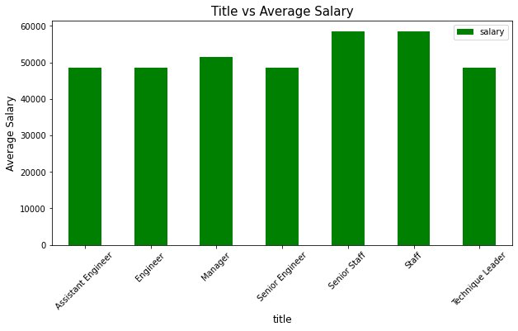

In [13]:

*# check to see what the boss was talking about*

check_my_id **=** employees_df[employees_df['emp_no'] **==** 499942]

check_my_id

*# details show that I was set up and he was trying to check me out - hopefully I meet expectations!*

Out[13]:

|  | **emp_no** | **title_id** | **birth_date** | **first_name** | **last_name** | **gender** | **hire_date** |
| --- | --- | --- | --- | --- | --- | --- | --- |
| **168736** | 499942 | e0004 | 1963-01-10 | April | Foolsday | F | 1997-02-10 |